Circuit Layout for the Arduino Joystick Workshop

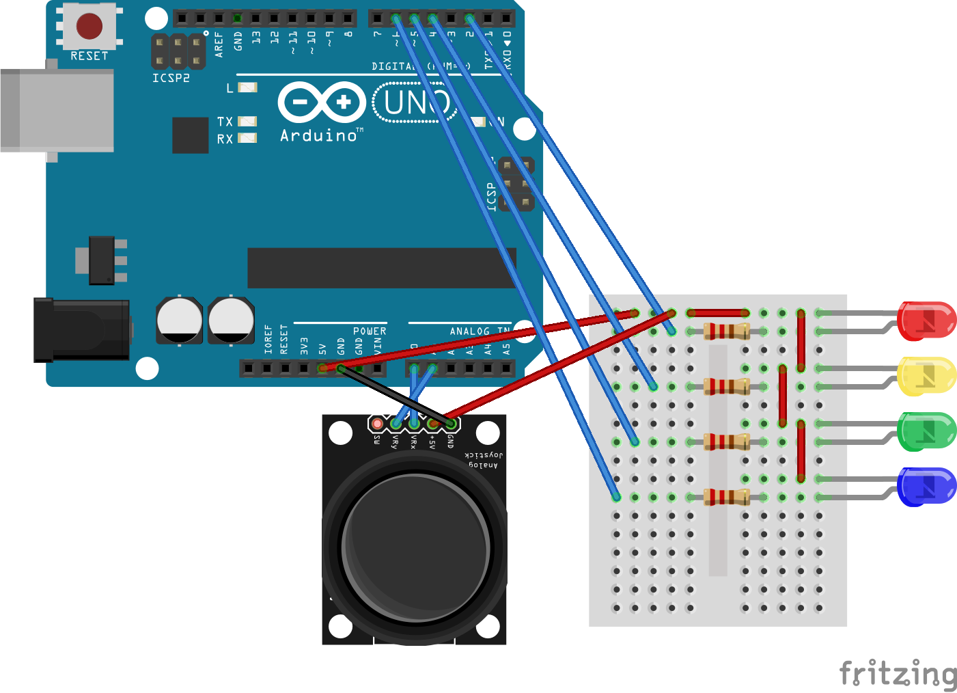

**Explanation**

A joystick is made up of two potentiometers (variable valued resistor), one going in the x-axis direction, and the other going in the y-direction. Each potentiometer adjusts the voltage at the output pins between 0 and 5V. The analogue to digital converter on the Arduino converts this to a 10- bit integer (0 to 1023). When the joystick is kept in its original position, the ADC (and hence your code) should read values close to 500-520.

We will go through some coding activities to demonstrate individual components. Note that since the IO pins on the Arduino are connected to the LED cathodes, the LEDs will be turned on when the IO pins are driven low. (Extension question, why is it set up like this?)